Communication &
Attitude Training
Manual

Onecall Hospitality Limited



Please answer the following questions

- Read questions 1 – 10
- Write your name at the top right hand side of this page
- Underline it
- Put the date at the top left hand side of this page
- Place a smiley face beside the number 4
- What are you doing on New Year’s Eve this year?
......................................................................................
......................................................................................
- How long have you worked at this establishment?
- Do you enjoy your work? Yes / No
- Circle your name
- Answer question one only

AIM
By the end of this course, you should be able to:
- Understand the meaning of interpersonal skills
- Identify the main areas of non verbal communication
- Use the skills learned to improve social understanding of both yourself and your customers
- Identify and rectify any weakness in your own appearance and interpersonal skills
The main objective of this course is to draw attention to the importance of communication (verbal and non verbal), appearance, attitude, and ultimately confidence.

INTRODUCTION
How many times have you said or done something that on reflection you regret. It may have been during a telephone call, in a text message, in an email, on facebook, as a direct response to a superior, colleague or child’s request or just generally in the heat of the moment.
Our ‘actions’ also play a leading role in the way that we communicate with people – movement, posture, expression, and appearance all tell their own story.
It is important that we consider our attitude and communication strengths and weaknesses in order to benefit our lives in general and the lives of others.

BUSINESS SUCCESS
You each have a role to play within the business – i.e. management, front of house, housekeeping, food and beverage, cook, domestic, maintenance, gardening etc. – you are also a member of the sales and marketing team. The way you greet people and answer the telephone, and how you speak to guests and react to their needs, will dictate the future success or downfall of the business.
PROFIT OR LOSS!
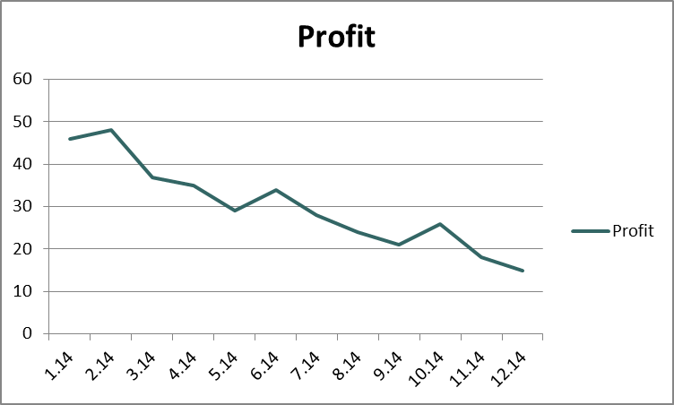
If it looks like this, you’re out of a job.

ATTITUDE

APPEARANCE | APPROACH

The 3 A’s of customer care are linked together and influence one another.
Attitude affects our Appearance which influences our Approach towards customers.

WHAT ARE INTERPERSONAL SKILLS?
Interpersonal skills are:
“The processes by which information is transferred immediately from and to a person or persons – done well.”
These processes can be through any or all of the following:
- Appearance dress, cleanliness, etc

- Speech greetings, conversation, speech tone, etc

- Posture you way you sit, stand, present yourself etc

- Eye contact looking into the eyes of your customer......or not!

- Gestures nodding, smiling etc

- Paralanguage tone, pitch, volume of voice

- Proximity your position in relation to others

CUSTOMER CARE AND SOCIAL SKILLS
To help us to adopt the best approach in our customer care, it is useful for us to be aware of the different types of behaviour our customers can show.
Customers are different

The guest you will never please
The hypochondriac
The gossip
The trouble maker
The dictator
The critic
The complainer
The disruptor
The aggressive type
The selfish type

With experience, understanding and adopting a professional attitude as explained in the following pages, you will become capable of handling these difficult situations. The golden rule is not to lose your patience and never argue back. All behaviour is caused; your job is to understand why and then deal with the situation. Don’t forget there are always more experienced staff available. If you are unable to cope with any situation, inform your supervisor.

ATTITUDE
First impressions are most important – make a good first impression and keep it up throughout the day. You are the customer’s main source of information and help; he / she needs to feel that you can deal efficiently with any queries. Consider these points when dealing with customers.
P - OSTURE

L - OOK AND LISTEN

E - XPRESSION

A - PPEARANCE

S - PEECH

E - AGERNESS TO HELP

COURTESY, THOUGHTFULNESS AND RESPECT
Genuine courtesy consists of understanding what our customers want and need. By showing thoughtfulness and respect you will indicate that you care and are concerned for your customers.
Do you take pleasure in helping others, even when they are not as courteous as they could be?
Do you:
- Address them how they wish (correct name and pronunciation)

- Always knock on their door before entering?

- Help without being asked

- Remember them if they have been before

- Involve imagination with your understanding? Customers like you to feel with them as well as for them.
Remember; always speak clearly and with respect, look at the customer and look interested. Use the customer’s name frequently.

SOME USEFUL COURTESY WORDS AND PHRASES
“Please”; “thank you”; “I would be happy to do that”; “can I help you please”; Come back and visit us”; “I am very sorry, Mrs Jones”; “Excuse me”; “Thank you for waiting”.

FRIENDLY GREETINGS
“Hello”; “Good Morning”; “Good bye”; “You’re Welcome2”; “It was nice talking to you Mr Smith”; “Is there anything else I can do for you”; “Thank you for calling”; “It’s a pleasure”

Use “please” whenever making a request of another person, including work colleagues. Acknowledge people immediately – look at them and greet them. Courteous behaviour – actions speak louder than words.
- Looking at people
- Smiling
- Making eye contact
- Pausing in your work to pay attention
= ARE ALL POWERFUL MEANS OF COMMUNICATION
As the saying goes “the customer is always right”

APPEARANCE
Appearance works in two ways. Firstly, if you look good, you’ll feel good. If you feel good, you’ll be more confident and therefore more likely to succeed in life.
Secondly, you are the first thing that your customer sees. If you look ‘tatty’, the customer will automatically assume that the product is too. Put yourself in the position of a customer who is looking for a venue for her daughter’s wedding. The domestic below is her first point of contact – what are your thoughts? What do you do? List your ideas...

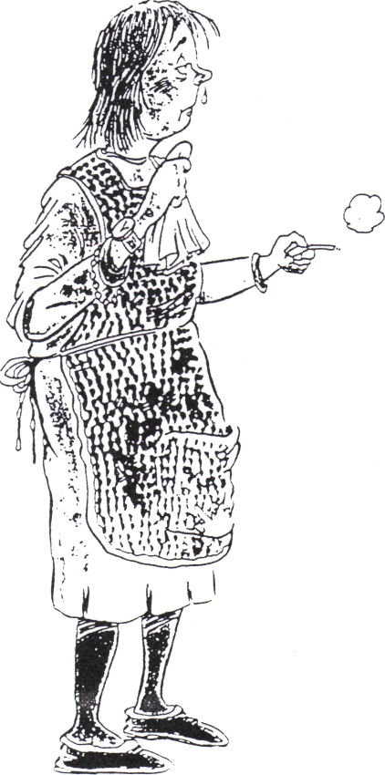

Your clothes don’t need to be designer labels, but they do need to be clean and tidy.
FACIAL EXPRESSION
Beware!!!!!
Your face reveals your feelings and most people will look at your face for a large part of a conversation. Not only will you show how you’re feeling (e.g. tired or interested) but how you also feel about the customer.
YOUR FACE REVEALS YOUR FEELING

We can tell a certain amount about our customers from their appearances. Use your eyes. It is polite to look at the person who is talking to you and it also gives you an opportunity to notice that person’s expressions.
Use your mouth - a smile can be the biggest icebreaker of all. Your mouth can show friendliness as easily as it reveals boredom and hostility. Make frequent visits to the dentist.
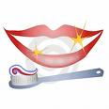
BEST FOOT FORWARD
You will find that you will get on much better with customers and they will get on much better with you if you make an effort to always put your best foot forward, especially in the way you look and dress. A scruffy looking member of staff tends to suggest that the person does not care much about what they are doing and it gives the establishment a bad reputation.

CLOTHING

Check your appearance constantly for the following points –they will be noticed by customers:
- clean and well laundered uniforms
- smartly worn
- name badge
- tights with no ladders
- appropriate clean footwear
- black socks for men
- no jewellery except wedding bands
REMEMBER – LOOKING GOOD MAKES YOU FEEL GOOD
BEAR IN MIND LOOKING GOOD COUNTS
Posture
Good posture can indicate clearly you are going to be helpful and can help you too.
- It’s good for your figure
- It will help stop aches and pains
But the effect of a good posture can be spoilt if you make a lot of gestures, indicating restlessness, “not sure feeling” etc. E.g. fidgeting with watch / ring, yawning, playing with hair, picking nose or nails, tapping fingers / foot / pen, biting nails, looking at watch, scratching.

HYGIENE

Your personal hygiene is an indication of the standards of hygiene our guests will expect. An immaculate member of staff reflects that everything else is equally clean and fresh.
Particularly noticeable are:-
- Your Hands

Keep your nails trim and make sure your hands are clean before tending to guest’s needs or handling food. If you have to do particularly dirty jobs, either wear gloves or ensure that you have scrubbed your hands afterwards. If your employer provides water free anti bactericidal hand wash, use it regularly.
- Your Hair
Keep it clean so it is a pleasure to look at. Keep it off your face so that guests can see who they’re talking to.
- Personal Freshness
There are three danger points – breath, underarm and feet (and those other parts we don’t mention!!)
- General Hygiene
Regular bathing is essential. There is nothing worse than being served by a member of staff with body odour. Some of your work will be of a more physical nature, causing a certain amount of perspiration.
- Scents
Scents if used should not be intrusive. Do not use deodorants in place of a bath or shower.

HELP YOURSELF TO CREATE GOOD IMPRESSIONS

Approach
Some guests will react very quickly to situations – if treated with respect as an individual they will respond to that.
Thoughtfulness
You may not know the reason for a guests visit.
Respect for privacy
Do not invade a guest’s privacy.
Good Timekeeping
Guests and workmates depend on your being on time. Our customers like a regular daily routine, so do not let the rest of your team down by being late on duty or rushing through your tasks and cutting corners. Make sure you get a goodnight’s sleep.
Commitment
You need total commitment to do your job. You may be called upon to carry out tasks beyond the scope f your bog description or take on extra duties when a colleague is sick. You have to be prepared to work at any time, weekends, Holidays, Christmas and the millennium. Guests want and need you. Can you honour your commitments and be flexible.
Understanding
An effective member of staff is able to adapt his/her behaviour according to the “needs” of the guest. We must react with understanding and sensitivity to each customer in each situation. Be a good listener and be interested in what the customer is telling you. Handle each situation with understanding and be efficient and quick in taking action.
Summary
The skills you develop in treating each guest and each situation differently, but with commitment, understanding, sensitivity and discretion will make your job interesting and stimulating. You will also ensure that a happy, Friendly atmosphere exists in the Hotel at all times if you remember this basic check list of points when offering “customer care”

CHECK LIST

ATTITUDE

Positive
If we expect to do well we will succeed and maintain a cheerful and friendly manner.

Courteous
Be polite, whatever the circumstances. Avoid losing your temper with “awkward! or “difficult” customers. Make guests feel welcome.

Attentive
Listen, show interest, be alert and observe all customers; give then your undivided attention. Look for changes to normal circumstances. Get help if necessary

Helpful
You are there to provide a service, demonstrate that at all times. Avoid having “favourites”, however difficult this may be.

Caring
Make the customer feel they matter, that they are individuals and not one of the crowd.

Enthusiastic
Enjoy providing a service and show the customer you are happy to help; put energy into it.

APPREARANCE

Dress
Always wear the appropriate uniform; tidy and clean to reflect a positive image of your workplace.

Voice
Always convey interest, warmth and sincerity

Body language
Confident gestures and posture will express positive verbal communication/information.

Smile
People respond to a smile, it is contagious and puts others in a more receptive mood.
Eye contact
It is a way of acknowledging people, of building a relationship, establishing “rapport” and making customers feel welcome.

Confident
If you approach the customer with confidence you develop trust.

Knowledge

The customer must be assured that you know how to do your job professionally with competence and efficiency.

- Always recommend alternatives and extras.
- If you see an empty glass, offer to fill it up.
- In the restaurant after main course, offer dessert, coffee, liqueurs etc.
- In the lounge after snacks is an opportunity to view the restaurant menu.
- Always follow up sales calls and send appropriate current and valid hotel literature.
- Inform guests, old and new, of calendar of establishment’s events.

SELF ASSESSMENT – CUSTOMER CARE AND SOCIAL SKILLS

Record in the following pages incidents where you have handled situations well, or how your behaviour could have been better.

Situation | How Handled

COMMUNICATION – VERBAL

After a customer has seen you, he/she will hear you. Even if speaking to someone on the telephone, the first few minutes of the conversation – what you say and how you say it – can either make or break a business proposal. Most of us have met the monosyllabic assistant in a shop, who doesn’t bother to look up when you enter and is more interested in her nails rather than assisting you. This behaviour is dictating to us that she is disinterested. The big multi-nationals however, have done extensive research into customer relations. We are greeted by a smile and a cheery word and made to feel that nothing is too much trouble. Everyone feels special.

How do you greet visitors?

......................................................................................................................................................

......................................................................................................................................................

......................................................................................................................................................

......................................................................................................................................................

......................................................................................................................................................

Do you consider yourself to be a good listener? How often, after putting down the telephone, do you wish you had taken the name of the caller and possibly a message and were you day dreaming and only listening to half of the conversation?

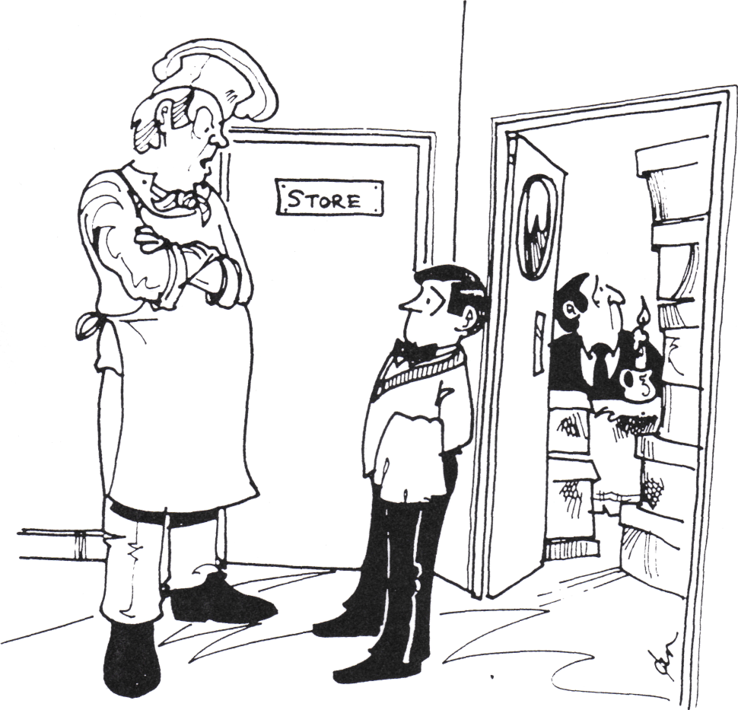

“Did you put those boxes in the other room like I told you?”

If tasks are to be done satisfactorily, clear standards of performance must be met

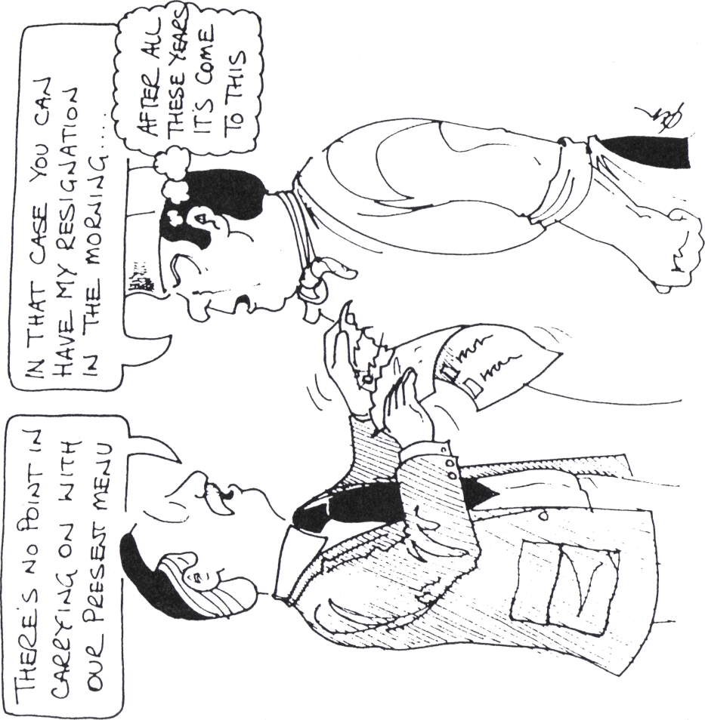

LISTENING SKILLS

- Try to concentrate on what you are listening to and try to cut out distractions. It’s often difficult to work, at busy lunch times, for instance, to listen to your supervisor because of all the distractions. But if you listen, it shows both at the time and later when you are not able to do what has been asked of you.

- Try to concentrate on what is being said, rather than the way it has been said. This is difficult in conversation, but useful when you are listening to someone who has been talking for a long time. If possible take notes to help you remember.

- Try to hear what is actually being said, rather than what you expect or wish to hear.

- In conversation, listen all of the time to what is being said. It is very easy to find yourself thinking about what to say next at the expense of listening. If you are a nervous person, take deep breathes.

- Finally, it is very difficult to listen effectively and talk at the same time. Sometimes it is better to listen to what is being said and have your turn another time.



When a guest approaches you, always greet with a friendly face and if unknown, ask them the purpose of their visit. Never leave guests standing if they have a while to wait – offer light refreshments. If they are enquiring about your place of work answer questions in a positive manner and introduce them to your supervisor. If the supervisor is not available, write their details down and pass this information to someone who will follow the purpose through.

When answering the telephone, speak clearly and with a friendly tone. Always take the name and telephone number of the caller if the person they wish to talk to is not available. Always pass messages onto the appropriate person.

ACTIVITY – LISTENING SKILLS
Let’s test your listening skills;-

A: One-way communication – you have five minutes to complete this activity

- Sit back to back with a partner
- Study the diagram page 15 and explain it for your partner to draw – your partner must not ask any questions.

Evaluate results

......................................................................................................................................................

......................................................................................................................................................

......................................................................................................................................................

......................................................................................................................................................

B: Two-way Communication – reverse roles - you have five minutes to complete this activity

- Sit back to back with a partner
- Study the diagram page 16 and explain it for your partner to draw – your partner may ask questions.

Evaluate results

......................................................................................................................................................

......................................................................................................................................................

......................................................................................................................................................

......................................................................................................................................................

COMMUNICATION – NON-VERBAL
Non-verbal communication includes any kind of communication that doesn’t use words. It is another way of transmitting and receiving information to and from other people. We make and receive non-verbal signs whenever we are with others. These signs are not words, but they often used with words. They affect the meanings of what we say. They are produced by various uses of our bodies. These non-verbal signs can be placed under seven main headings:-

- POSTURE

- EYE CONTACT

- PROXIMITY AND EYE CONTACT

- GESTURES

- PARALANGUAGE

- DRESS

- PERSONAL HYGIENE

TELEPHONE SKILLS

To the caller your voice reflects a guest’s expectation of your establishment. When the telephone rings, the answer you give will determine the success or downfall of the establishment.

WHEN RECEIVING A CALL

- Answer promptly, clearly and with a smile.
- Find out who the caller needs to speak to.
- Don’t leave the caller in the dark.
- Be Sympathetic.
- Offer an available and realistic alternative.

Answering techniques

- Answer the phone promptly, within four rings to avoid irritation from the caller.

- Your opening words should be business like, efficient, warm and friendly.
“Good morning ................”

- Your voice must to be clear and friendly. One way of doing this is to put a smile on your face as your talk. Your pleasantness communicates itself to the caller as if by magic! Remember the caller cannot see your face, your voice must convey your interest.
- 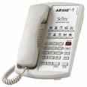

- Offer to help. Sometimes the caller will not know who he/she should speak to. Politely enquire to the nature of the call so you may identify the person the caller needs to speak to. Give the caller the name of the individual and explain you shall try to connect him/her with the caller.

- If there is to be a delay obtaining the individual (on the extension or in getting the caller to the phone) apologise for the delay. Keep the caller informed as to what is happening. i.e. “The person you require is unable to take the call at the moment, but will be with you shortly.”

Offer to take a message, or give the caller a chance to call back later.

“Can I take a message for him/her?” or “I’m sorry, the person you require is still unavailable, do you wish to call back later, or can I take a message?”

- Thank the caller for his/her call and let him/her ring off first in case there is an afterthought.

When answering an internal extension, identify your work area or department, introduce yourself e.g. kitchen, can I help you?

WHAT IS A COMPLAINT?

What is the definition of a complaint?

This includes any written or verbal expression of dissatisfaction or disquiet relating to the treatment a guest receives. This could relate to the actions of staff or their failure to act, or their delay in taking action which causes some disquiet to the individual guest.

Is there a system which allows for open access to the complaints procedure?

Ensure that as an employee, you have been told verbally or been given a written statement of the company complaints procedure and the philosophy underlying it?

Complaints should be dealt with straight away in an informal way wherever possible by the staff directly responsible; this will stop the complaint material from becoming exaggerated.

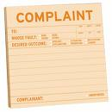

DEALING WITH COMPLAINTS

In a way we should welcome complaints. Handling complaints allows us to have closer contact with our customers and help us to provide a better service and product. It gives us the chance to turn a dis-satisfied customer into a satisfied one.

Try to distinguish however, between complaints that are genuine and justified from those that are false and unjustified. In both cases work back to the root cause – you main find the complaint is not as justifiable as you first thought. The complaint may come to you because you happen to be on the spot. Do not take it personally, but adopt the following techniques:

ALWAYS LISTEN | It allows the customer to have their say. Never interrupt. Do not take the complaint personally and NEVER lose your temper
APOLOGISE | Soothe the situation and show concern. Use the customer’s name.
ASK QUESTIONS | Find out the real reasons for the complaint
ACTION | Offer a course of action agreeable to the customer. “A man convinced against his will, is of the same opinion still!”
TAKE ACTION | The key to the success of handling a complaint is the speed in which you do it. If you receive a letter of complaint deal with it straight away.
CHECK THAT EVERYTHING IS ALRIGHT | If the customer is still in the workplace after the initial complaint, check that everything is now alright. Once is enough, do not invade the guests privacy, you may make the matter worse.
REPORT TO MANAGEMENT | If you are not in charge, management must be made aware of episodes which have upset customers. Most complaints are genuine and we can learn from them to make our business more successful.
LEARN | All complaint handling is a learning experience:  - How can similar complaints be avoided in the future?  - How could we have dealt with the complaint more efficiently?

Good customer care will reduce complaints. Do not assume that because you don’t get complaints, there aren’t any.
- ALWAYS LISTEN
- BRING IN THE BOSS IF NECESSARY
THANK AND APOLOGISE

The information in this document is confidential. You can download content and print copies of the information, only for your own personal use. All other rights are reserved. Unauthorized reproduction, modification, and or distribution are not permitted. No loss or costs incurred arising from this document content will be accepted by Onecall Hospitality Limited. The advice given is for guidance only. Copyright ©
Document Ref: OCH_CATM267

