Cashing Up Slips

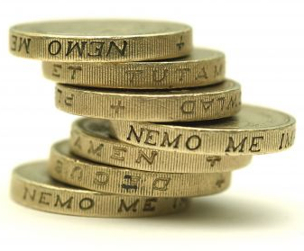

Date:

Onecall Hospitality Limited


Cashing Up Slip Dated
Employee Name
Shift AM/PM
Cheques & Cash
Cheques
100 Pounds
50 Pounds
20 Pounds
10 Pounds
5 Pounds
2 Pound Coins
1 Pound Coins
50 pence coins
20 pence coins
10 pence coins
5 pence coins
1 & 2 pence coins
Total Cheques & Cash
Less Starting Float
- Cheques & Cash to Deposit
Cash Receipts
(Discrepancies) Cash Over (Short)
- Credit Card Charges – TOTAL
- Credit Card Tips – TOTAL
Declared Tips – TOTAL
SALES TOTAL (A + B)
Bank Deposits
Cheques & Cash to deposit (A) - TOTAL
Less Credit Card Tips (C) - TOTAL
DEPOSIT TOTAL (A – C)
Employee Signature

The information in this document is confidential. You can download content and print copies of the information, only for your own personal use. All other rights are reserved. Unauthorized reproduction, modification, and or distribution are not permitted. No loss or costs incurred arising from this document content will be accepted by Onecall Hospitality Limited. The advice given is for guidance only.
www.onecallhospitality.com
Document Ref: OCH_WP267

